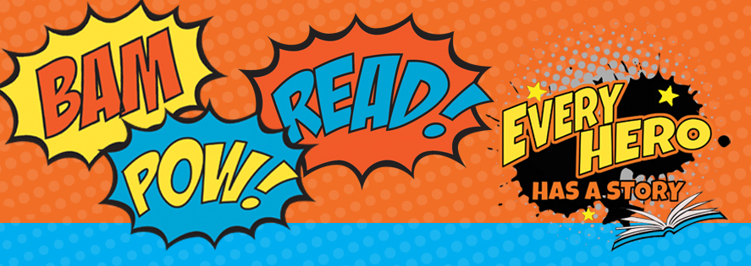

Every Hero Has a Story! Book Review: Story Retell
(Use the backside of paper if necessary. Draw a picture on another page to add to your review!)
Child’s Full Name:____________________________
Book Title:______________________________
Author:_________________________________
Characters: List the main characters

Settings: Where did the story take place?

Kick Off: How did the main story happen?

Feelings: Were the main characters, happy, sad, afraid?…etc

Events: List some events that happened in the story

Ending: How did the story End?

Feelings: How would you rate this book? Use a star rating 1-5 *5 stars=Best book, *1 star=You did not care for this book!

Moral: What did you learn from the story?

